Ans 1:-

select month(event_time)as month,year(event_time) as year,(count(product_id) * price) sale from events group by month order by month desc;

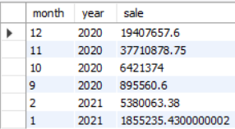

Ans 2:- select hour(event_time),count(event_time) as number_of_visits from events where event_type='view' or event_type='cart' group by hour(event_time) order by count(event_time) desc limit 24;

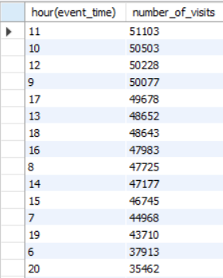

Ans 3:- select (count(product_id) * price) as sale,brand from events group by brand order by sale desc limit 6;

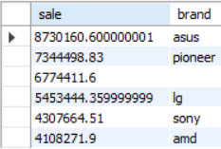

Ans 4:- select (count(product_id) * price) as sale,count(category_id) as category_counts, category_code from events where event_type='purchase' group by category_id order by category_counts desc limit 6 ;

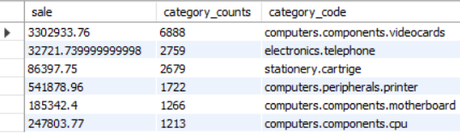

Ans 5:- select user_id, count(user_id) as users_count, event_type , event_time from events where event_type='purchase' and month(event_time) in (9,10,11,12,1,2) group by user_id;

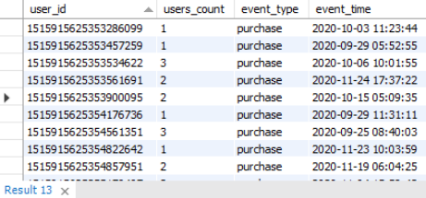

Ans 6:- select user_id, count(event_type) as actual_view from events where event_type in ('purchase','view') group by user_id

